HOMEWORK II (Part 1/2/3/4) Report

Summary what has been done:

* RTL level design (16 bit counter)
* Pre-synthesis simulation
* Synthesis
* Post-synthesis simulation

Required tools:

* Lab: NC-Verilog, Debussy (nTrace & nWave), Design Compiler(dv)
* Ubuntu: Icarus Verilog (iverilog), gtkwave, Dia

Learned lessons:

* Stuck:
  + Unfamiliar with Verilog language.
  + Design 16 bit counter with 8 bit counter modules.
  + Draw block diagram.
* Find:
* Exciting things:

16 bit counter Design:

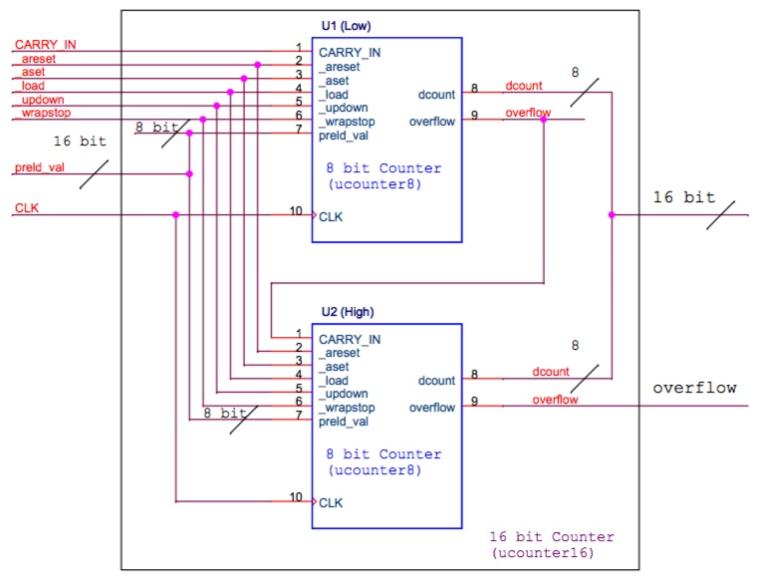

Part 1-1 pre-simulated waveforms:

* Test: load 13 instructions(Fig.1-2) to IM

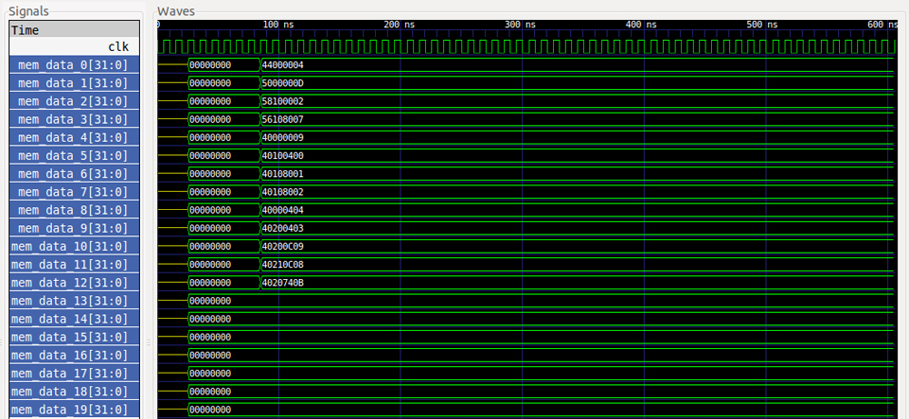

* Test 1(marked in red block): MOVI (R0=20'd4)
* Test 2(marked in blue block):ADDI (R0=R0+4'b1101)
* Test 3(marked in yellow block): ORI (R1=R0|4'b0010)

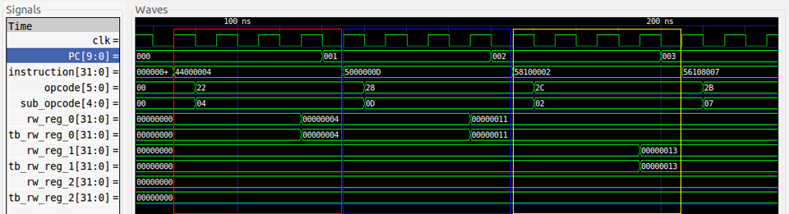

* Test 4(marked in red block): XORI (R1=R1^4'b0111)
* Test 5(marked in blue block): NOP
* Test 6(marked in yellow block): ADD R1=R0+R1

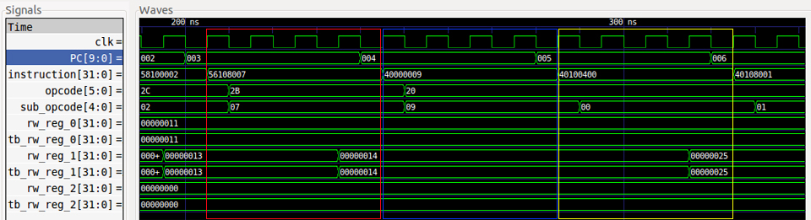

* Test 7(marked in red block): XORI (SUB R1=R1-R0)
* Test 8(marked in blue block): AND (R1=R1&R0)
* Test 9(marked in yellow block): OR (R0=R0|R1)

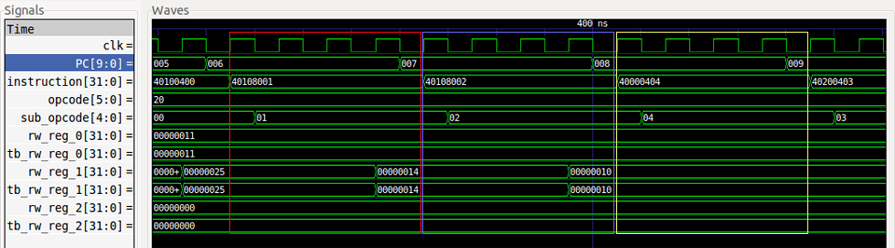

* Test 10(marked in red block): XOR (R2=R0^R1)
* Test 11(marked in blue block): SRLI (R2=R0 SRL(3))
* Test 12(marked in yellow block): SLLI (R2=R2 SLL(3))

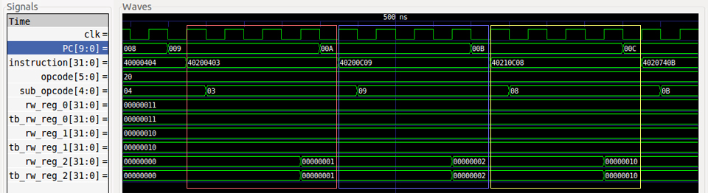

* Test 13(marked in yellow block): ROTRI (R2=R0 ROTR(29))

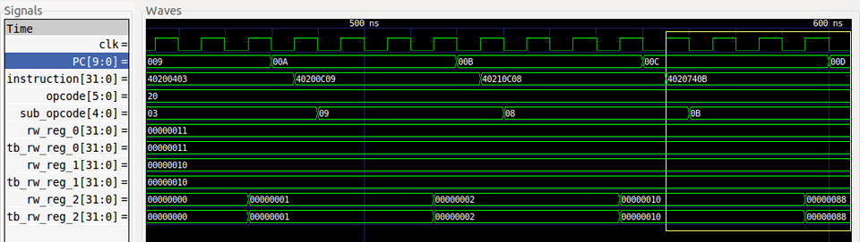

Part 1-2 pre-simulated waveforms:

* Test: load 20 instructions to IM

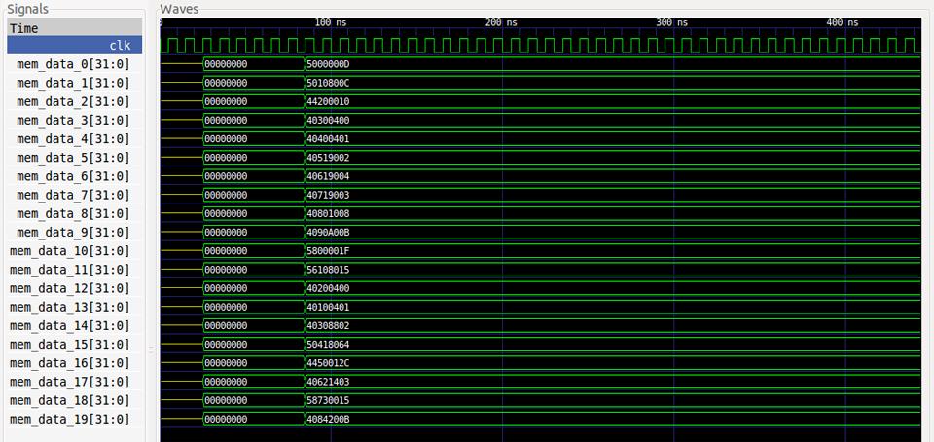

* Test 1(marked in red block): ADDI (R0=R0+5’b01101)
* Test 2(marked in yellow block): ADDI (R1=R1+5’b01100)

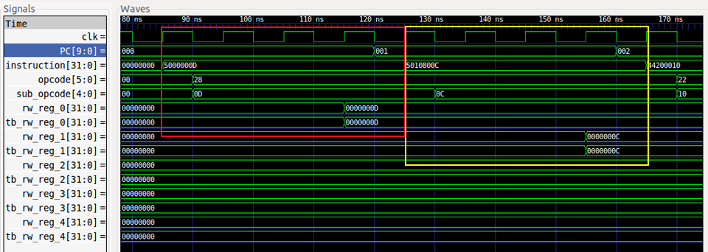

* Test 3(marked in red block): MOVI (R2= 5’b01000)
* Test 4(marked in yellow block): ADD (R3=R0+R1)

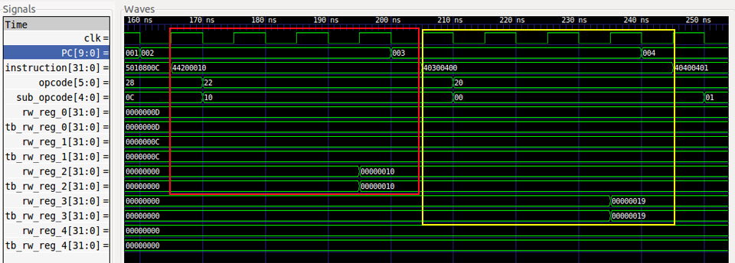

* Test 5(marked in red block): SUB (R4=R0-R1)
* Test 6(marked in yellow block): AND (R5=R3&R4)

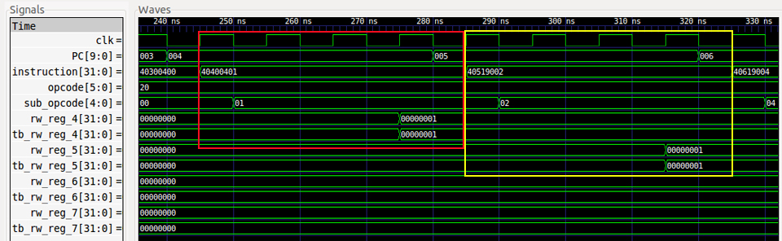

* Test 7(marked in red block): OR (R6=R3|R4)
* Test 8(marked in yellow block): XOR (R7= R3^R4)

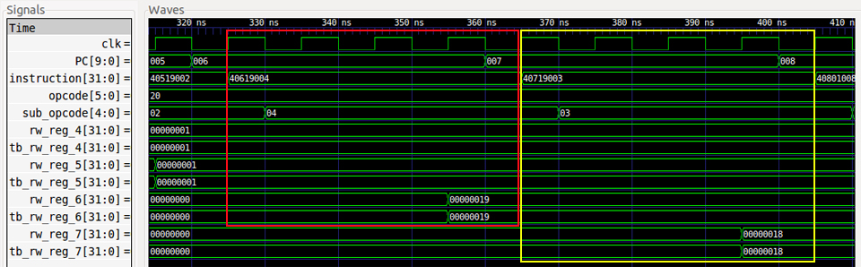

* Test 9(marked in red block): SLLI (R8=R0<<5’b00100)
* Test 10(marked in yellow block): (R9=R1>>5’b01000)

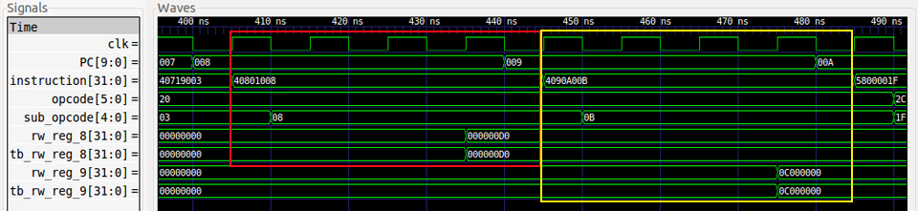

* Test 11(marked in red block): ORI (R0=R0|5’b11111)
* Test 12(marked in yellow block): XORI (R1=R1+5’b10101)

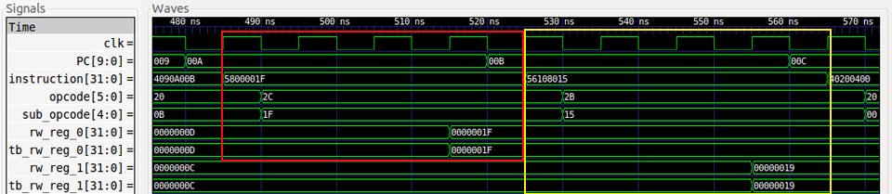

* Test 13(marked in red block): ADD (R2=R0+R1)
* Test 14(marked in yellow block): SUB (R1=R0-R1)

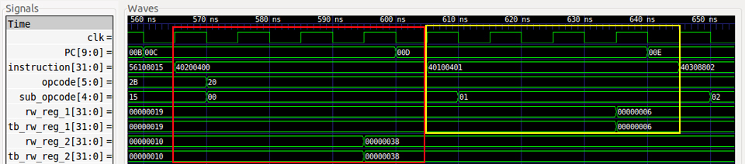

* Test 15(marked in red block): AND (R3=R1&R2)
* Test 16(marked in yellow block): ADDI (R4=R3+’d100)

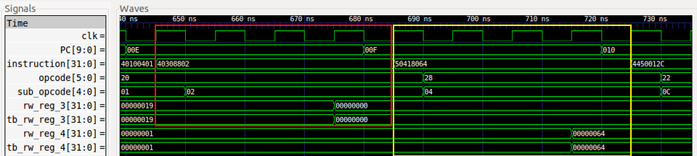

* Test 17(marked in red block): MOVI (R5=’d300)
* Test 18(marked in yellow block): XOR (R6=R4^R5)

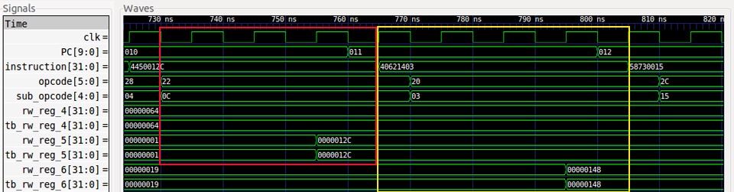

* Test 19(marked in red block): ORI (R7=R6|5’b10101)
* Test 20(marked in yellow block): ROTRI (R8=R8 ROTR(5’b01000) )

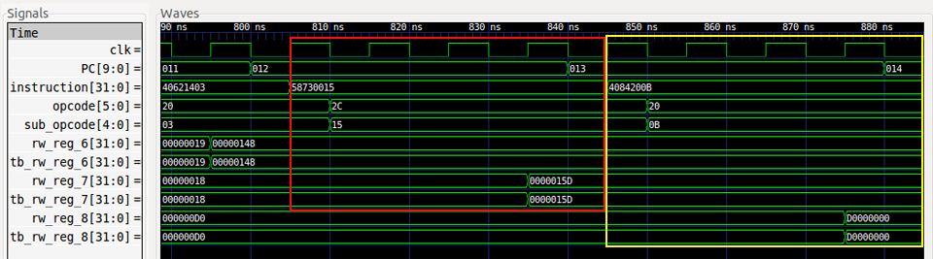

Part 1-3 pre-simulated waveforms:

* Test: load 20 instructions to IM

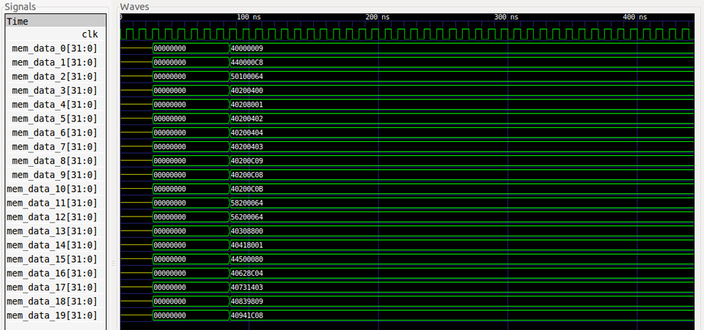

* Test 1(marked in red block): NOP
* Test 2(marked in yellow block): MOVI (R0=’d200)

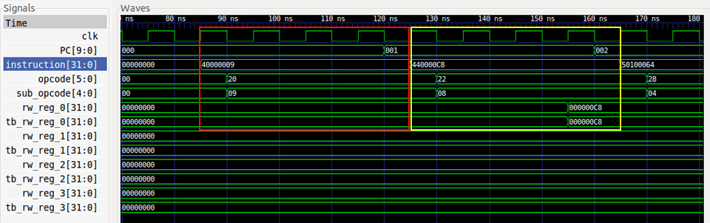

* Test 3(marked in red block): ADDI (R1=R0+’d100)
* Test 4(marked in yellow block): ADD (R2=R0+R1)

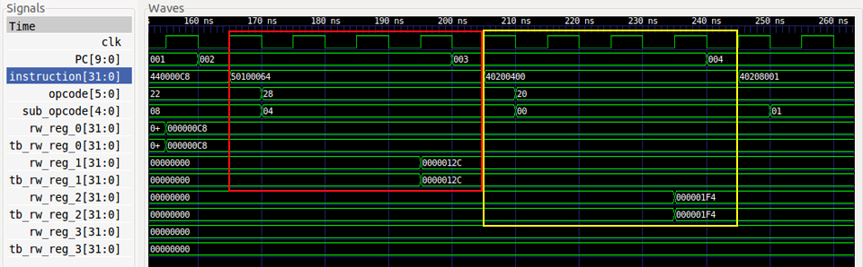

* Test 5(marked in red block): SUB (R2= R1-R0)
* Test 6(marked in yellow block): AND (R2=R0&R1)

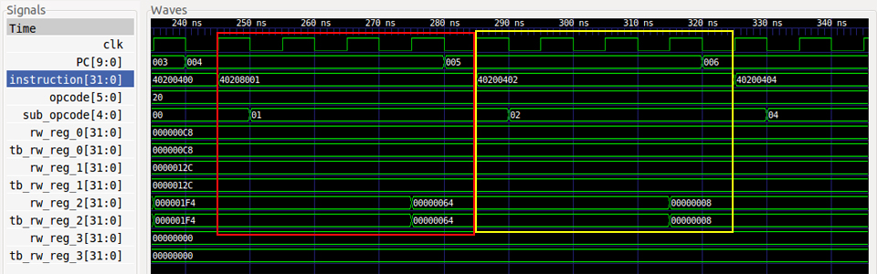

* Test 7(marked in red block): OR (R2=R0|R1)
* Test 8(marked in yellow block): XOR (R2=R0^R1)

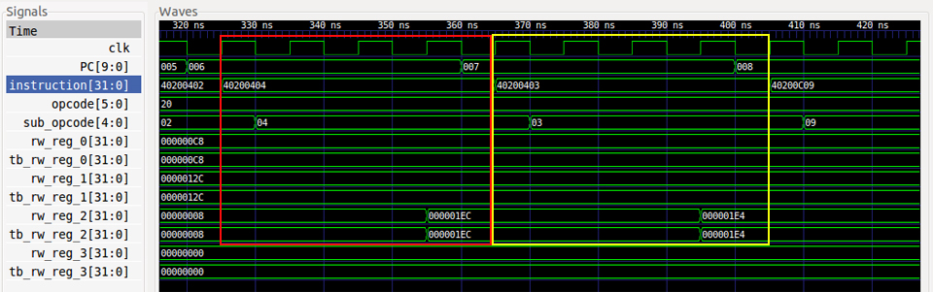

* Test 9(marked in red block): SRLI (R2=R0>>’d3)
* Test 10(marked in yellow block): SLLI (R2=R0<<’d3)

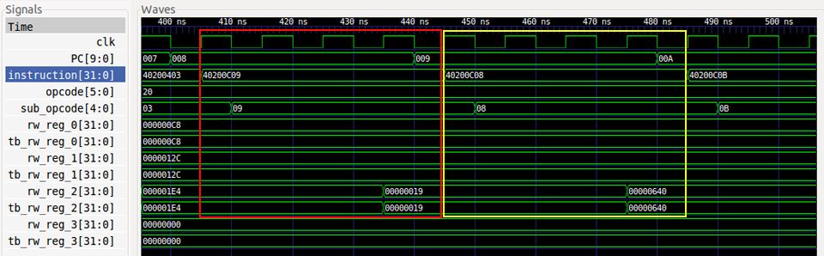

* Test 11(marked in red block): ROTRI (R2=R0 ROTR(3))
* Test 12(marked in yellow block): ORI (R2=R0 |’d100)

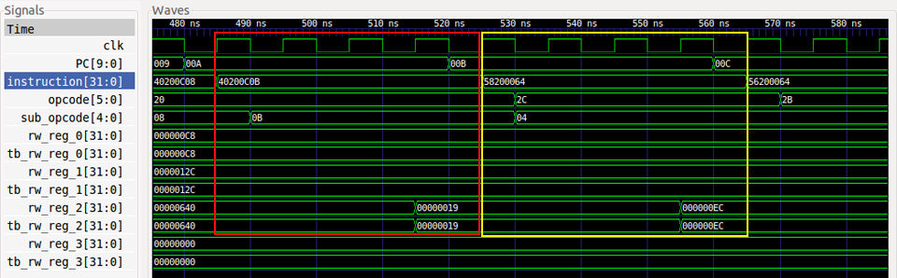

* Test 13(marked in red block): XORI (R2=R0^’d100)
* Test 14(marked in yellow block): ADD (R3=R1+R2)

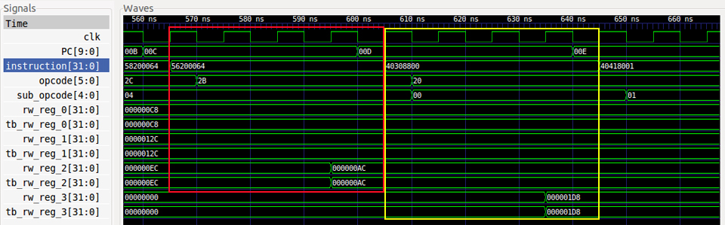

* Test 15(marked in red block): SUB (R4=R3-R0)
* Test 16(marked in yellow block): MOVI (R5=’d128)

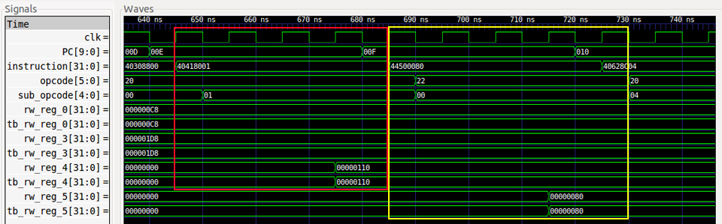

* Test 17(marked in red block): OR (R6=R5|R3)
* Test 18(marked in yellow block): XOR (R7=R6^R5)

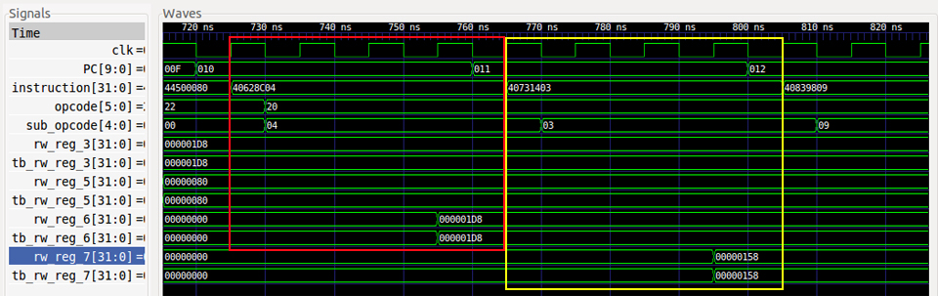

* Test 19(marked in red block): SRLI (R8=R7>>’d6)
* Test 20(marked in yellow block): SLLI (R9=R8<<’d7)

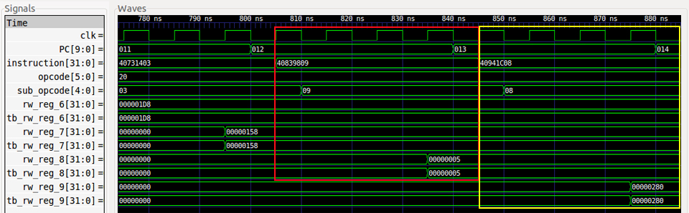

Post-simulated waveforms: